Defence evasion by disabling eventlog service report:

Since case is disabling service start search with disable.
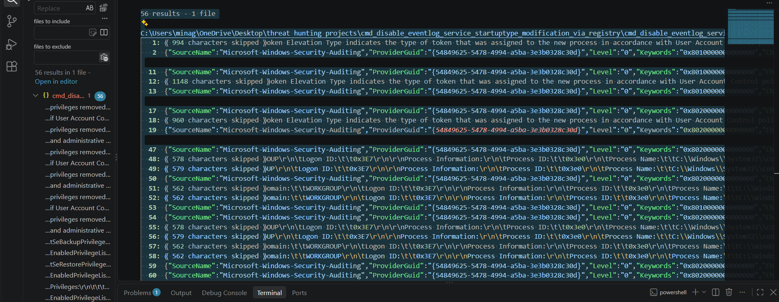

Search for eventlog service 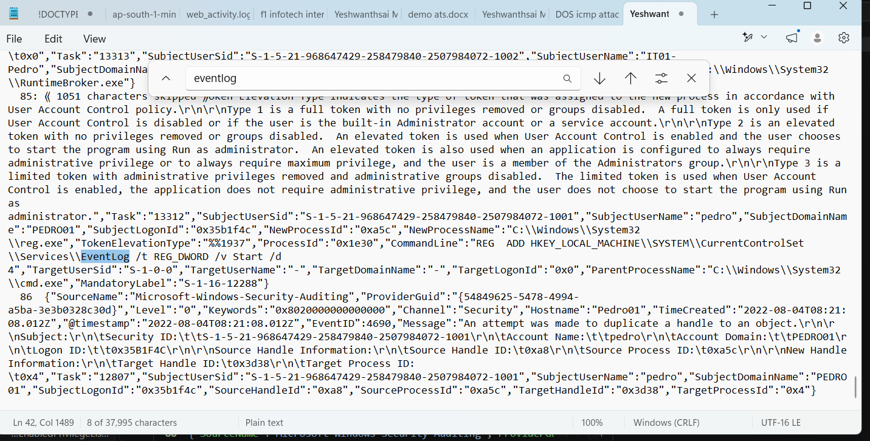
We find REG ADD HKEY_LOCAL_MACHINE\\SYSTEM\\CurrentControlSet\\Services\\EventLog /t REG_DWORD /v Start /d 4"

Overall activity:
The reg is used to disable the service name eventlog where start 4 is type disable

